# Citizen Curators RCM Project information:

**‘Diversifying our interpretations of the collections’**

The first project will explore European objects depicting Africans and also our objects from Africa, culminating in an on-line exhibition for Black History Month in October.

The second will be looking at sexuality (Sex and Desire as a template) culminating in an on-line exhibition in February for LGBT history month. Throughout their time here the CC’s will produce one piece of on-line content per week. They could take it in turns to post/publish or work in pairs or as a group. The posts will relate to the work that they are undertaking and/or will contribute to the on-line exhibitions.

*Deadline for Royal Cornwall Museum applications is 31st August 2019. Applicants must be able to attend all of the East workshops on specified Mondays and come to the Museum one day per week during the course. Induction session on 18th September 2019.*

# Application Questionnaire for Citizen Curators

Name:

Email address:

Telephone number (mobile preferred):

Host museum:

1. What do you love most about the Royal Cornwall Museum?
2. In your opinion, what top three qualities/skills/talents should a good curator have?
3. What hobbies and talents do you have that you can bring to your museum?
4. Why would you be a good Citizen Curator?
5. In your opinion, how and where could the museum share collections stories?
6. Do you/are you able to use the following? (underline/circle as relevant)*
   1. Word or other word processing software
   2. Email
   3. Library catalogues
   4. Social media e.g. Twitter, Facebook, Instagram
   5. Other digital skill (please specify)
7. Do you have any access needs that we can help you with?
8. 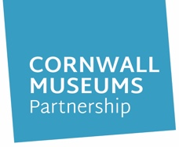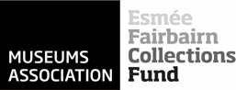Apart from unforeseen emergencies or illness, can you attend all of the Core Sessions and work on collections projects at your museum?
9. Anything else you’d like us to know about you?

*\*Please note: We operate a digital first policy for the Citizen Curators programme. This means you will receive most of your course materials and resources via email or to download from a website.*